CIS-420-01

Digital Dream Team

FALL 2020

Assignment #5

Mohammed Al Madhi, Joseph Baxter, Kyle Cousin, Keith Camp, Matthew Smith, Eric Lopez-Gutierrez

**Progress Report**

By Digital Dream Team

**SCOPE AND PURPOSE**

Our project focuses primarily on updating the system for the Office of Research and Innovation, pointing out the various ways they can benefit from the updates that we can provide.

The purpose for updating the system will help students, staff, and others feel more comfortable and confident in their education now and years to come. This will encourage them to appreciate how far the University of Louisville has come and also enhance the learning of our university, as well as the community.

**PROGRESS**

To date, the Digital Dream Team has completed our statement of work, described our business rules, and defined our entity relationship diagram. As stated in our statement of work we have defined our work requirements, along with mapping out the schedule that leads us to the completion of this project.

**ADDITIONAL WORK**

Two key tasks are to be completed in this upcoming week. As stated within our schedule/milestone section of our statement of work, we each plan to have our first peer evaluations and project proposal completed. We also plan to begin the functional code for prototyping during this upcoming week. During the process of beginning our functional code, we also plan to make a concrete decision on which project management tool to use.

**REMAINING QUESTIONS**

Questions remain regarding the unexpected problems or issues that we may encounter in attempt to complete this project. How will the team respond during Covid-19? How will the team collaborate effectively given the limitations on face to face meetings?

**EXPECTED RESULTS**

We expect to find that as we continue to define our goals and set our dates that we will greatly improve the system for the Office of Research and Innovation. With these improvements we expect that we will discover research and innovation more efficiently and accurately.

We have used some of our CIS 320’s Prototypes to show how our Website Design would look as we have agreed that this is the design that we will use to build the website.

We have also included few pictures from the actual website design that we currently built.

Figure 1 below is what we imagine the new and improved landing page would look like. It has a new infographic that can be used to show off any interesting statistics. It also has a new widget used to search for connections. The events widget is an upgrade over the current one. This landing page also prominently features the R&I social media.



Figure 1

Live view of the actual Website in Progress..

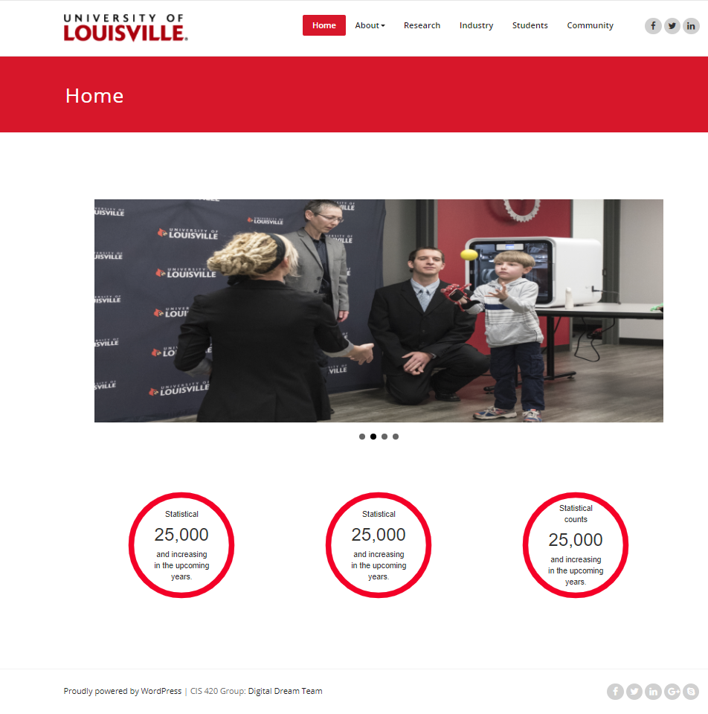

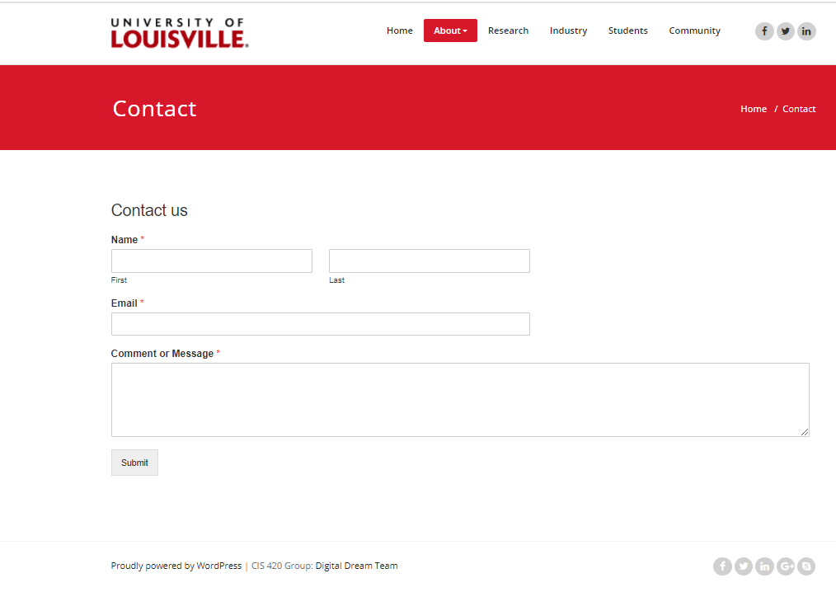

Figure 2 below shows what the community landing page might look like. Considering there was not an existing one on the current R&I website, we took a few liberties in putting what we thought should exist on the page.



Figure 2

Figure 3 below shows what a new industry landing page might look like. Since there is not an existing page dedicated to industries on the site currently, we added what we thought would be beneficial for those stakeholders to see.



Figure 3

Figure 4 below shows what a new researcher landing page might look like. It includes a direct login to iRIS as well as a drop down for forms and a section for funding. It also includes infographics for each of the main facility types. At the base, there is a section for any relevant links



Figure 4

Figure 5 below shows what a new student landing page might look like. It features two sections for undergrad and graduate students that will contain any relevant information. It also has an events section and placeholders for videos. We saw that the current version included a few videos, so we wanted to ensure those were accounted for.



Figure 5

Figure 6 below shows what users might see when they look up the core research facilities that R&I offer. The current version is almost too minimal. This lets users scroll through existing facilities then click and expand the options to get more information. A link is provided that will take users to a separate page where all relevant information on each facility is located.



Layout 4 below is what a user would see if they were to fill out an industry request form. This is nearly identical to the existing IR form that exists on the site now. It didn’t need much changing.



Creating a newsletter(admin Preview)

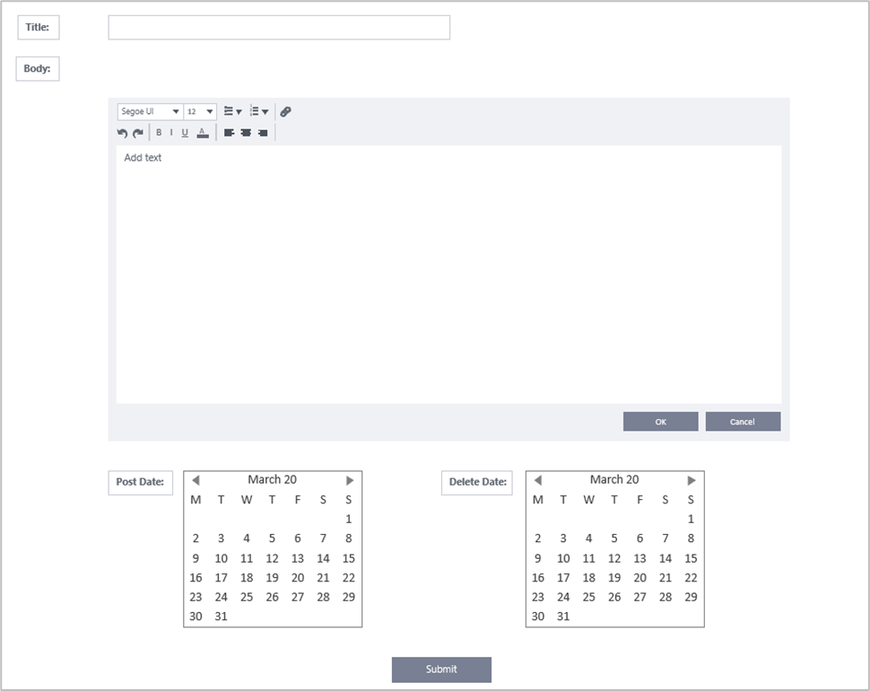

(Admin View)



This prototype demonstrates the contact us form that students and visitors can use to contact the Office of Research and Innovation.

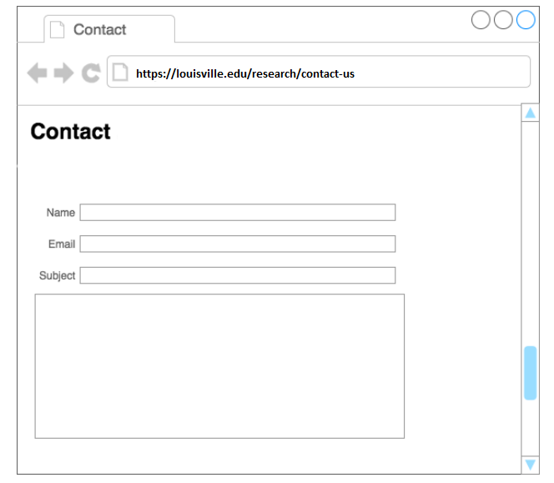

Layout 10



This Prototype demonstrates what an administrator interface looks like when accessing the admin portal.

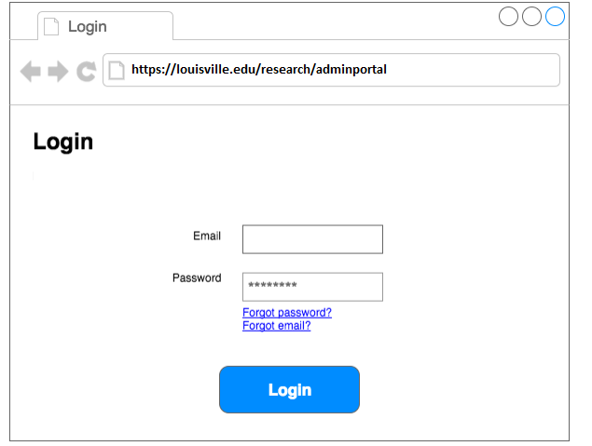

Layout 11

